Adhip Kashyap

# Adhip Kashyap

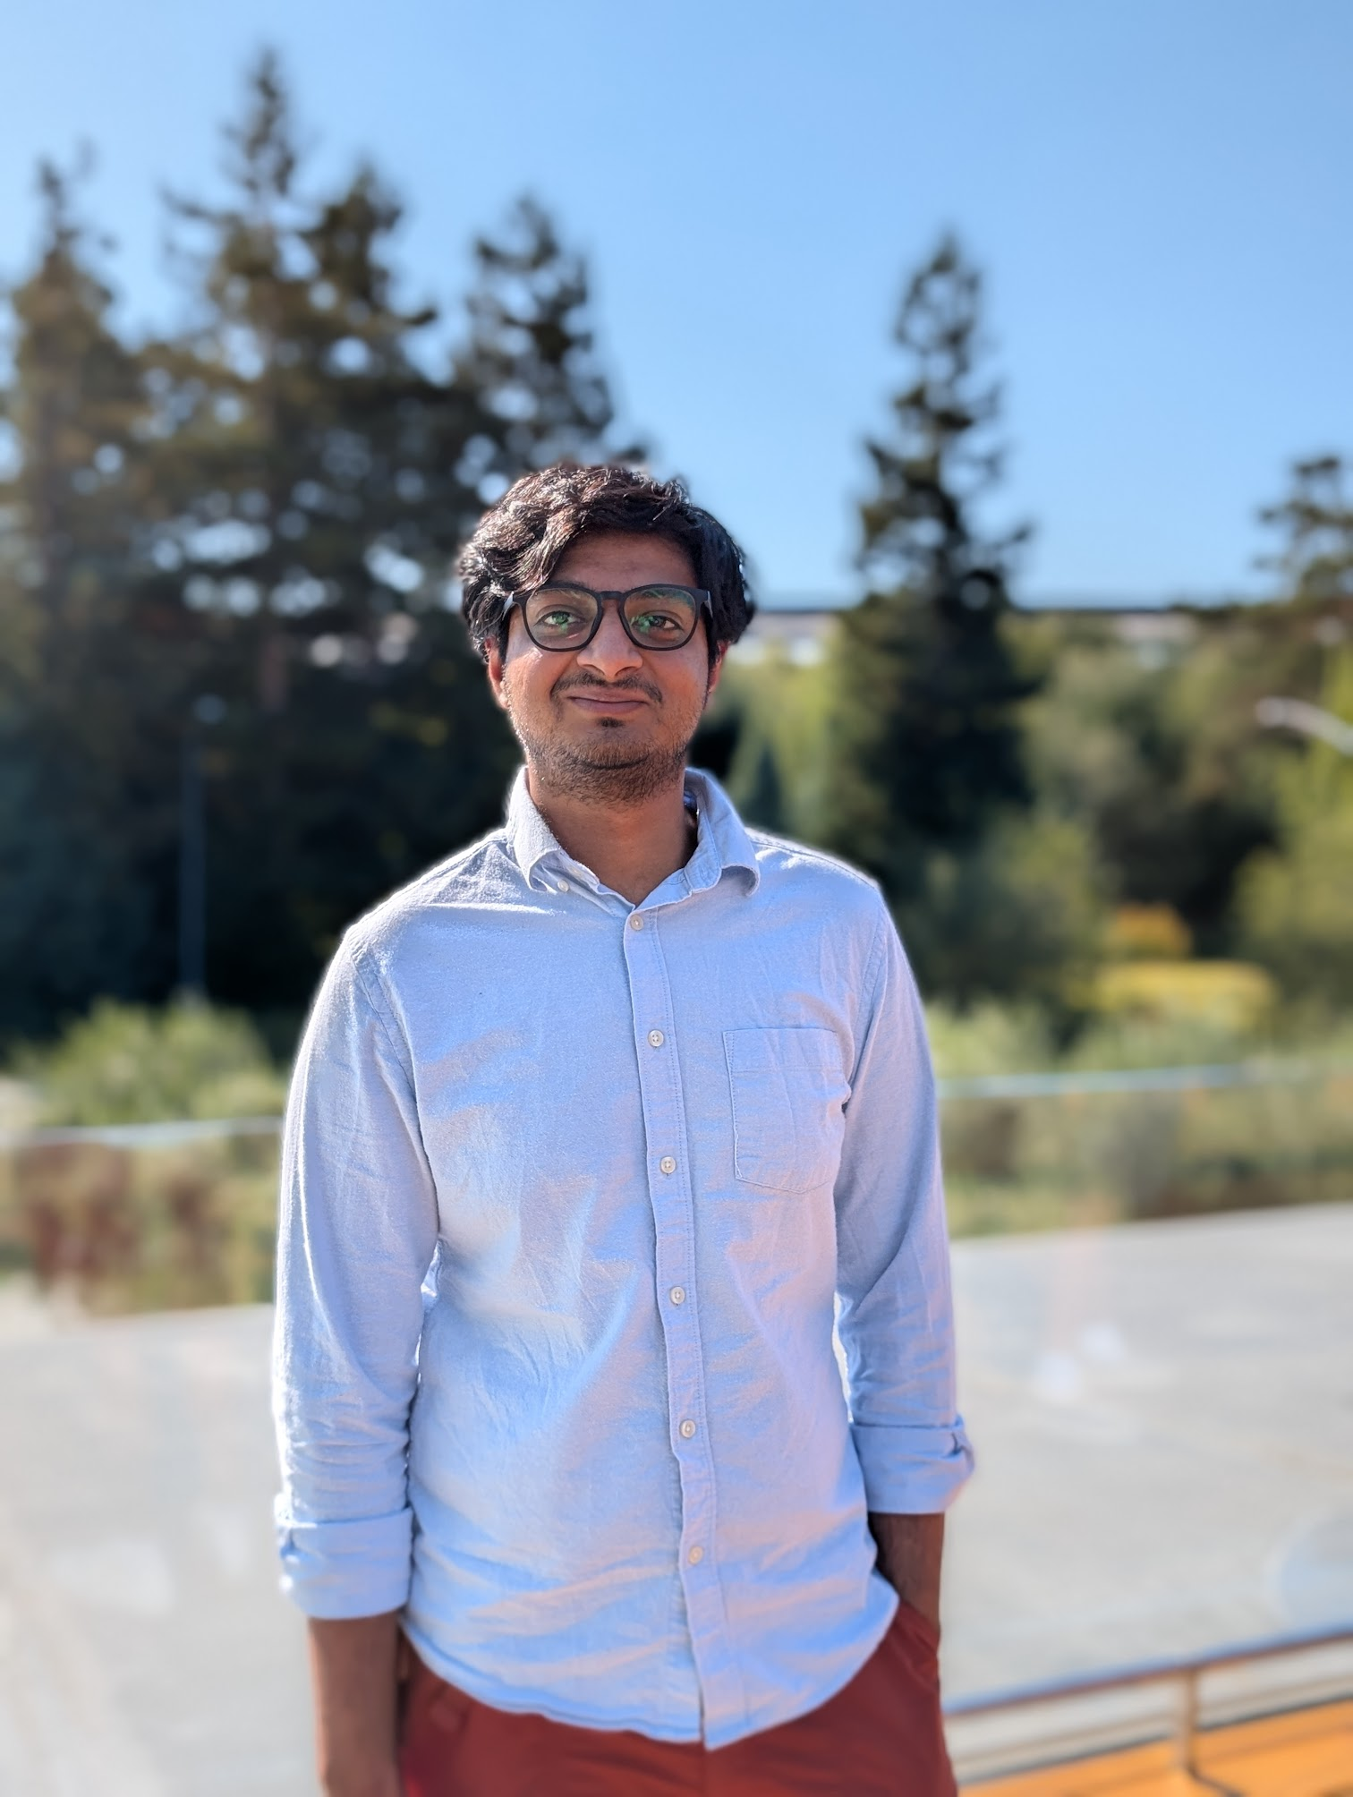

Save PDF

(602)-515-5187 | [adhip.kashyap@gmail.com](mailto:adhip.kashyap@gmail.com) | Thousand Oaks, California

[adhipk.dev](https://adhipk.dev) | [linkedin.com/in/adhip-kashyap](https://linkedin.com/in/adhip-kashyap) | [github.com/adhipk](https://github.com/adhipk)

## Skills

**Languages:** Java, Python, C/C++, TypeScript, Rust, GoLang, NodeJS | **Cloud:** AWS, Azure, GCP, Kubernetes, Docker, Terraform | **Frameworks:** Spring Boot, Next.js, React, Django, FastAPI, TensorFlow | **Databases:** PostgreSQL, MongoDB, Redis, Neo4j, DynamoDB

## Experience

### Hoag Hospital, Newport Beach, CA

**AI Software Engineer**

Oct 2025 – Present

* Faced with high call center volume, designed and deployed AI voice agents using GPT and Vapi to automate patient appointment scheduling, achieving 80% call deflection across 3,000+ monthly calls.
* Identified config drift issues across environments; implemented GitOps pipeline with Terraform to manage agent configurations, eliminating deployment inconsistencies between dev, stage, and prod.
* Needed reliable quality assurance for AI agents; built comprehensive eval harness with LLM-judged simulations, enabling automated regression testing and compliance reporting.

### TechAhead, Remote

**Client Solutions Architect**

Apr 2025 – Present

* Tasked with winning new clients, created technical architecture proposals and designed scalable backend systems, contributing to successful client acquisitions.
* Recognized inefficiency in proposal workflow; developed internal AI tools to automate proposal generation, reducing turnaround time significantly.

### Teaching Solved, Tempe, AZ

**Founding Engineer**

Aug 2024 – Mar 2025

* As first engineer, architected and built full-stack platform (Next.js, PostgreSQL, AWS) enabling 1,000+ educators to create, share, and monetize language learning resources.
* Users struggled to find relevant content; developed custom RAG-based search to surface culturally and linguistically relevant results, improving content discovery.

### InduzBuy, Bangalore, India

**Software Engineer Intern**

May 2023 – Aug 2023

* Legacy PHP codebase slowed development; led migration to Laravel framework, cutting feature lead time by 20% and reducing deployment errors by 40%.
* Manual data processing took 30+ minutes; built BERT-based classification model with 95% accuracy, reducing processing time to 30 seconds.

### ICICI Lombard GIC, Bangalore, India

**Software Engineer**

Oct 2019 – Aug 2022

* Infrastructure costs were unsustainable; migrated monolithic application to auto-scaling microservices architecture, reducing AWS costs by 30%.
* Slow premium calculations frustrated users; implemented Neo4j-based decision tree engine, improving computation speed by 40%.

## Education

M.S. Computer Science, Arizona State University

2022 – 2024

B.Sc. Mechanical Engineering (Minor: CS), PES University

2015 – 2019

## Projects

**LibriCasts** ([libricasts.adhipk.dev](https://libricasts.adhipk.dev)) — Built open-source tool integrating LibriVox audiobooks with PocketCasts, serving thousands of users.

**Downmark** ([downmark.fly.dev](https://downmark.fly.dev)) — Created webpage-to-Markdown converter handling JS-rendered content using Chrome Headless.

**Medical Videos Chatbot** ([Demo](https://medical-videos-chatbot.vercel.app/)) — Interactive chatbot for querying medical video content using NLP.

**Object Detection Benchmark** ([Demo](https://obj-detect-bench.vercel.app/)) — Benchmarking app comparing CNN architectures for on-device detection.